**Project Initialization and Planning Phase**

| Date | 19 March 2025 |
| --- | --- |
| Team ID | LTVIP2025TMID19942 |
| Project Name | Cosmetic Insights Navigating Cosmetics Trends and Consumer Insights with Tableau |
| Maximum Marks | 3 Marks |

**Define Problem Statements (Customer Problem Statement Template):**

Create a problem statement to understand your customer's point of view. The Customer Problem Statement template helps you focus on what matters to create experiences people will love. A well-articulated customer problem statement allows you and your team to find the ideal solution for your customers' challenges. Throughout the process, you’ll also be able to empathize with your customers, which helps you better understand how they perceive your product or service.

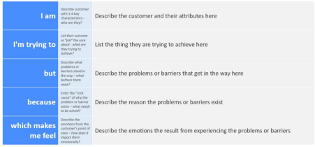

Reference: https://miro.com/templates/customer-problem-statement/

**Example:**

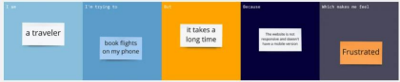

| **Problem**  **Statement (PS)** | **I am**  **(Customer)** | **I’m trying to** | **But** | **Because** | **Which makes me feel** |
| --- | --- | --- | --- | --- | --- |
| PS-1 | A cosmetic Brand manager | Identify emerging beauty trends | There is too much scattered and unstructured data | The industry rapidly evolves and i lack centralized insigths | OverWhelmed and unsure about strategic decisions |
| PS-2 | A data analyst | Analyse consumer preferences for cosmetic products | The available data is complex and difficult to interpret | I lack an interactive and visual way to explore patterns | Frustrated and inefficient in deriving insigths |